Expression of Interest for Early Years Provision at Cedars Park Community Centre
Pintail Road, Stowmarket
IP14 5FP

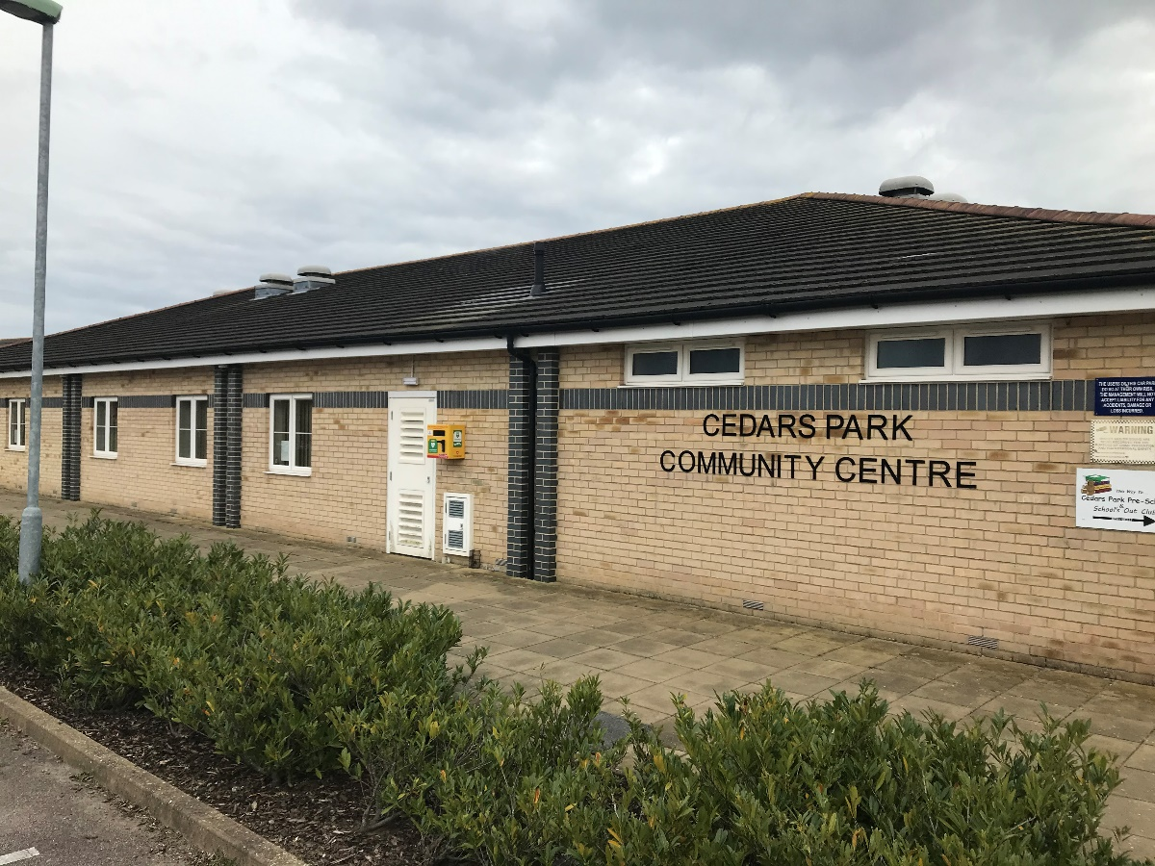
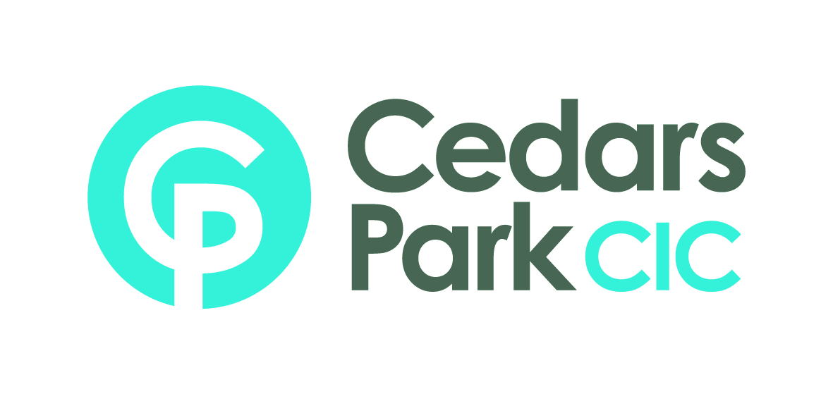

Cedars Park Community Centre opened in May 2013. The building is set within the heart of the Cedars Park estate and ideally placed next door to Cedars Park Primary School.
The local community is thriving with young families and continued development.
The Aviary at Cedars Park offer a sports bar and social club from the building. They open during evenings and weekends and support many local functions and events and have several sports teams using the facility. The community centre has one main hall with occupancy of 120 and two meeting rooms which can be used as one room occupancy of 30 each. The halls and meeting rooms are hired out to groups and for functions such as birthday parties, baby showers, charity events.
The community centre benefited from hosting a successful early years’ provision registered with Ofsted from June 2013. The owner retired from early years’ childcare in July 2021 and the preschool closed.
The community centre has partly been used by the NHS as a vaccination centre since October 2021.
There is an opportunity for a new provision to use the community centre as a base for a preschool and/or wraparound care for up to five days a week. There is need for another early years’ provider locally as there is low availability for registered childcare within the Stowmarket area.
The Hillyer Hall (main hall) has accommodated up to 24 preschool aged children, and negotiation can be held for the use of additional rooms (Ash and Beech) which has accommodated up to an additional 12 preschool aged children. The centre has a large, enclosed outdoor space with access from the Hiller Hall.
The centre was previously used for childcare provision from 7.30am to 6pm Monday to Friday but hours would need to be negotiated with the centre manager.

Expression of Interest Form
To be completed by the applicant:
Name
Phone Number
Email Address
Current Job Title
Current Field of Employment
Proposals for the setting

Please provide a description of your proposals for running and early years provision including any intended benefits to the local community.

Signature of Applicant:

Please return this form by email to: application@cedarsparkcic.co.uk
Closing date for submission: Friday 15th July 2022

